SWIM THE THAMES/ISIS EVENTS CALENDAR 2011
Date | Event | Details
13/11/2011 | Swim 17 | Jeremy and Sef will send details
3/12/2011 | OSS December dip | See OSS website. http://www.outdoorswimmingsociety.com/index.php?p=events&s=&id=81  Costs £15 if you want to swim. Supporters get in for a donation. Several of us have booked so you won’t be alone  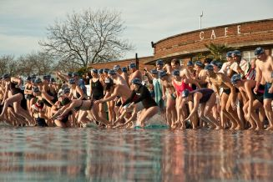
December | December swim | Jeremy and Sef will send details. Brrr
2/1/2012 | New Year get together | Jo and Chris have kindly agreed to organise this so await details. I feel sure that it will involve water (as in swimming) and food
February | February swim | Jeremy and Sef will send details. Still brrr
March | March swim(s) | We may we back to two swims per month by now. Jeremy and Sef will send details
29/4/2012 | Maldon Mud Race | http://www.maldonmudrace.com/main.htm  We are mad enough to have applied with a team of six so we may ask you to come along to support us as we flounder through knee high mud  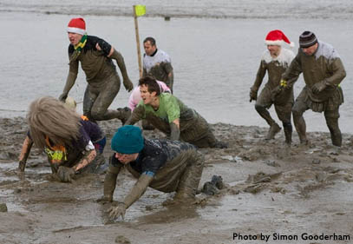
June/July 2012 | Dorset camping weekend | This will be a chance to taste salt water doing some of the lovely swims off the Dorset coast. We’ll try to coincide with a full moon. There is a lovely campsite at Burnbake on the Isle of Purbeck www.burnbake.com/ and we can try to include the Durdle Door to Lulworth Cove and Dancing Ledge swims. Pam organising  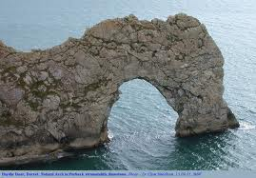
June to September 2012 | Great Swim Series
September 2012 | Dart 10k | Lots of us are thinking about this so please will someone let us know on the OSS Oxon elist when the list is open
? | Other things that you want to add?

